Requirement Review / Walkthrough / Inspection

Test Case ID: 3

Webpage URL: https://www.demoblaze.com/

● Scenario ID: 1
Scenario: View Products

Test Steps:
1. Open Website
2. Go to categories
3. And view product

Screenshots:-
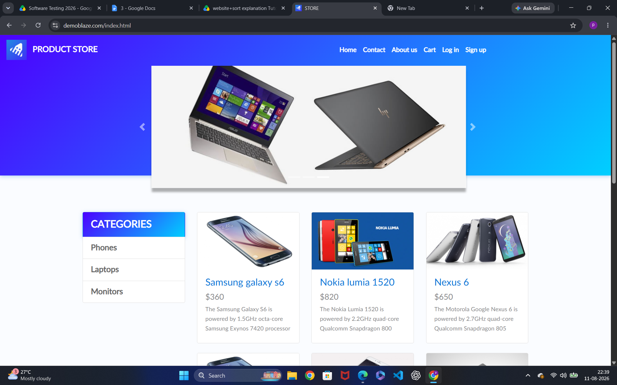

● Scenario ID: 2

Scenario: Select Products

Test Steps:
1. Select Product you want

Screenshot:

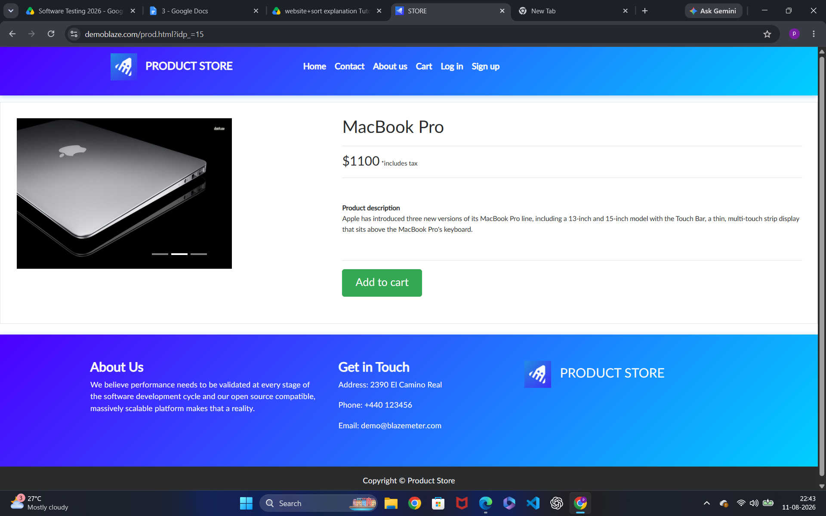

● Scenario ID: 3

Scenario: View Product details

Test Steps:
1. Tap on product details
2. Product Details

Screenshot:-

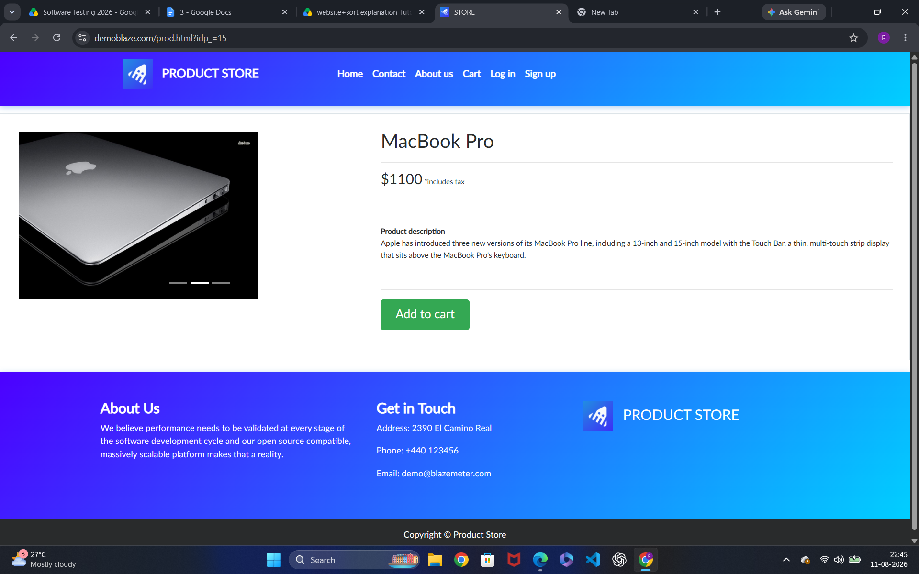

● Scenario ID: 4

Scenario: Add Product

Test Steps:
1. Add to cart Screenshot:

Screenshots:-

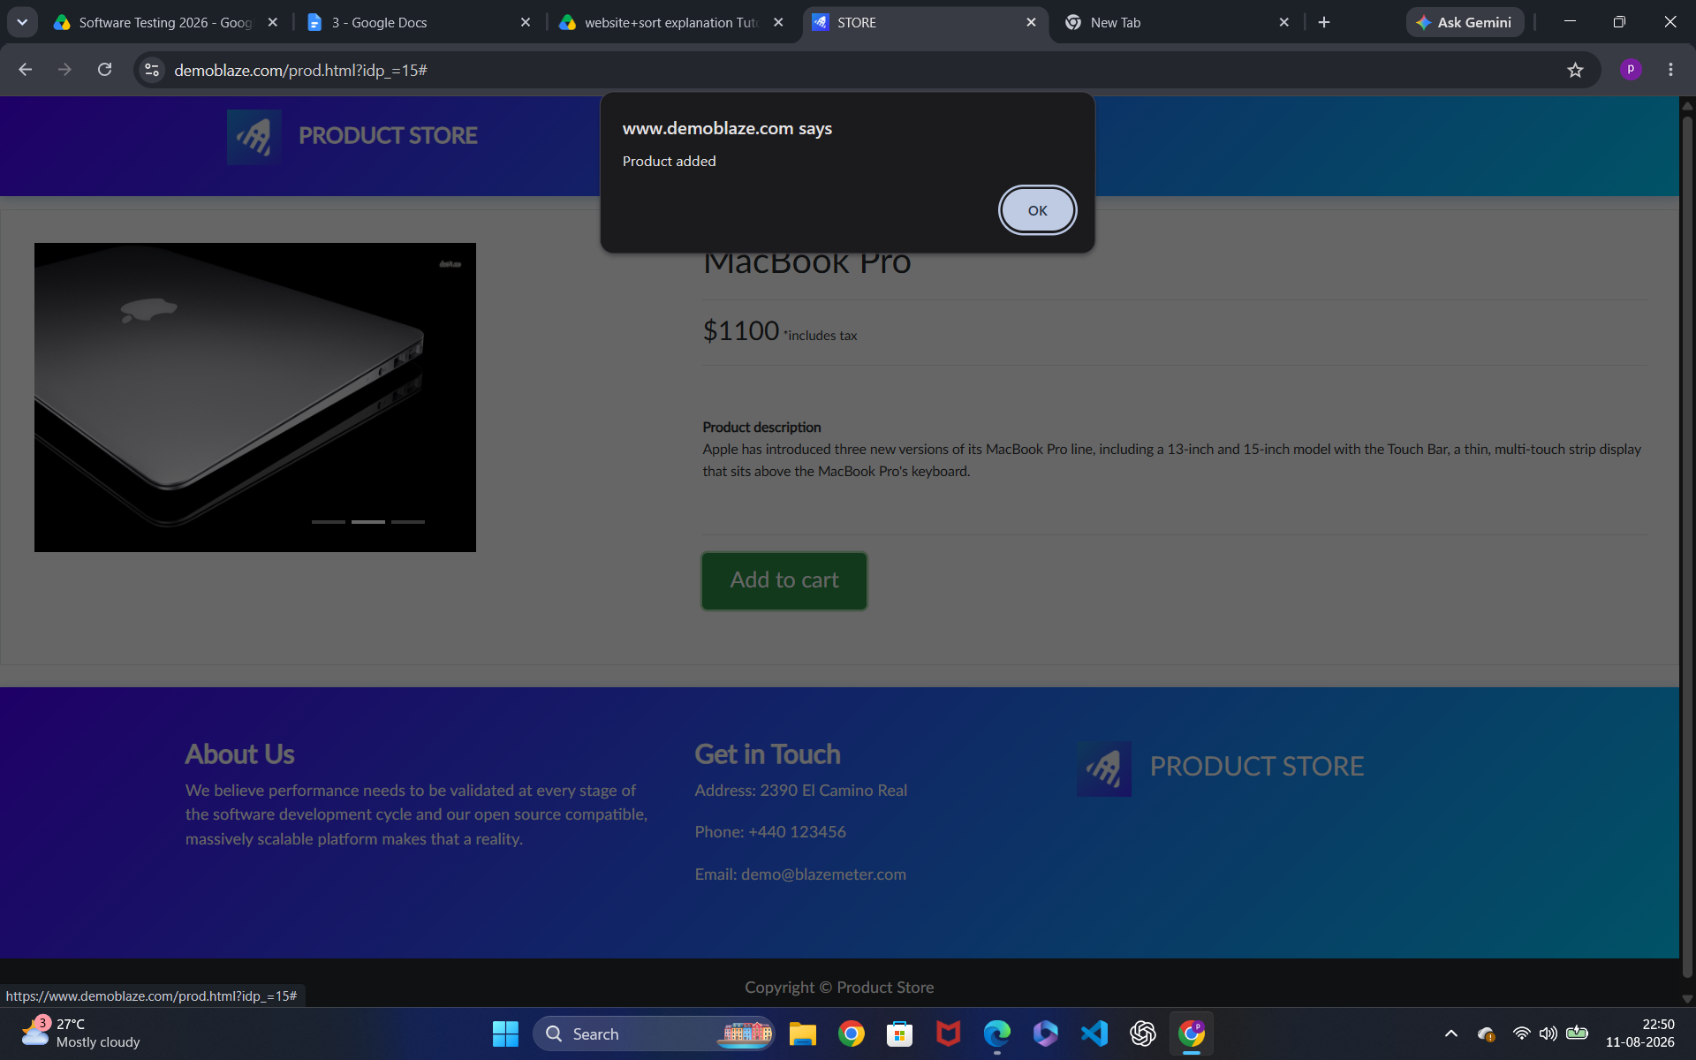

● Scenario ID: 5

Scenario: Open cart

Test Steps:
1. Tap on Cart icon

Screenshot:-

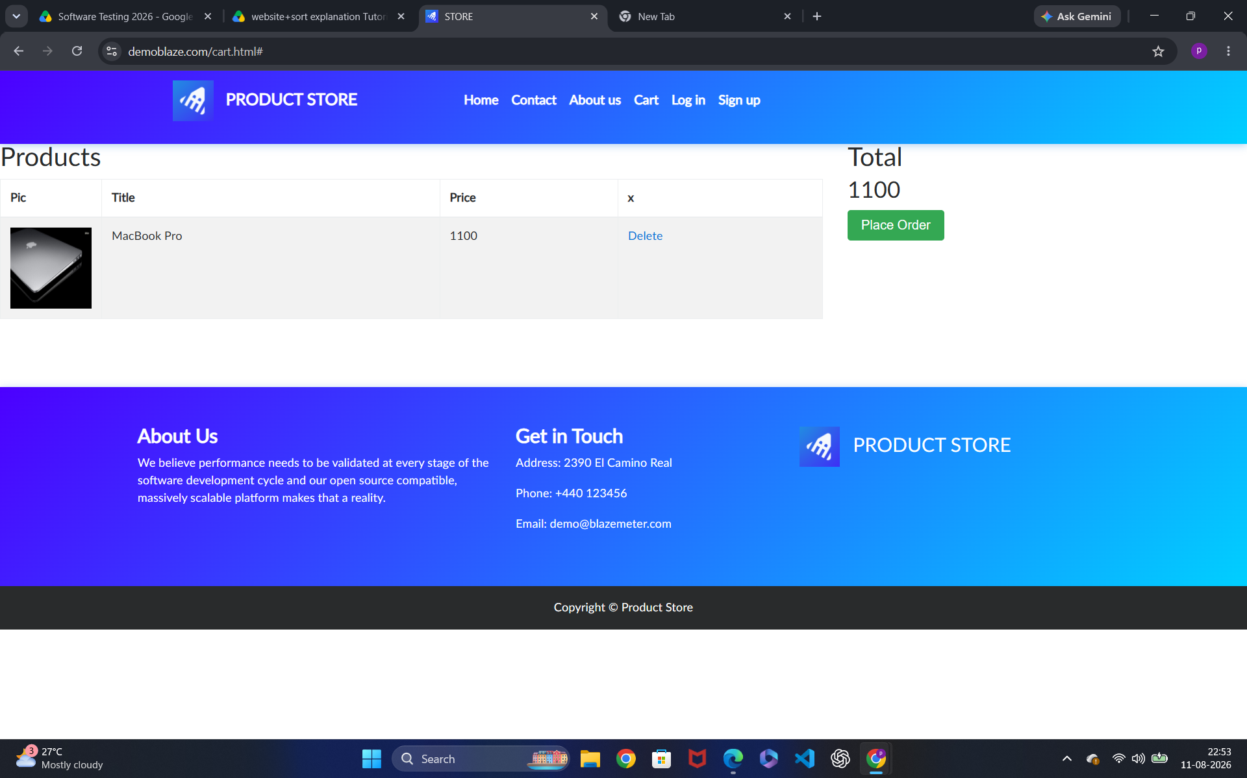

● Scenario ID: 6

Scenario: Verify Product in cart

Test Steps:
1. Check the added item

Screenshot:-

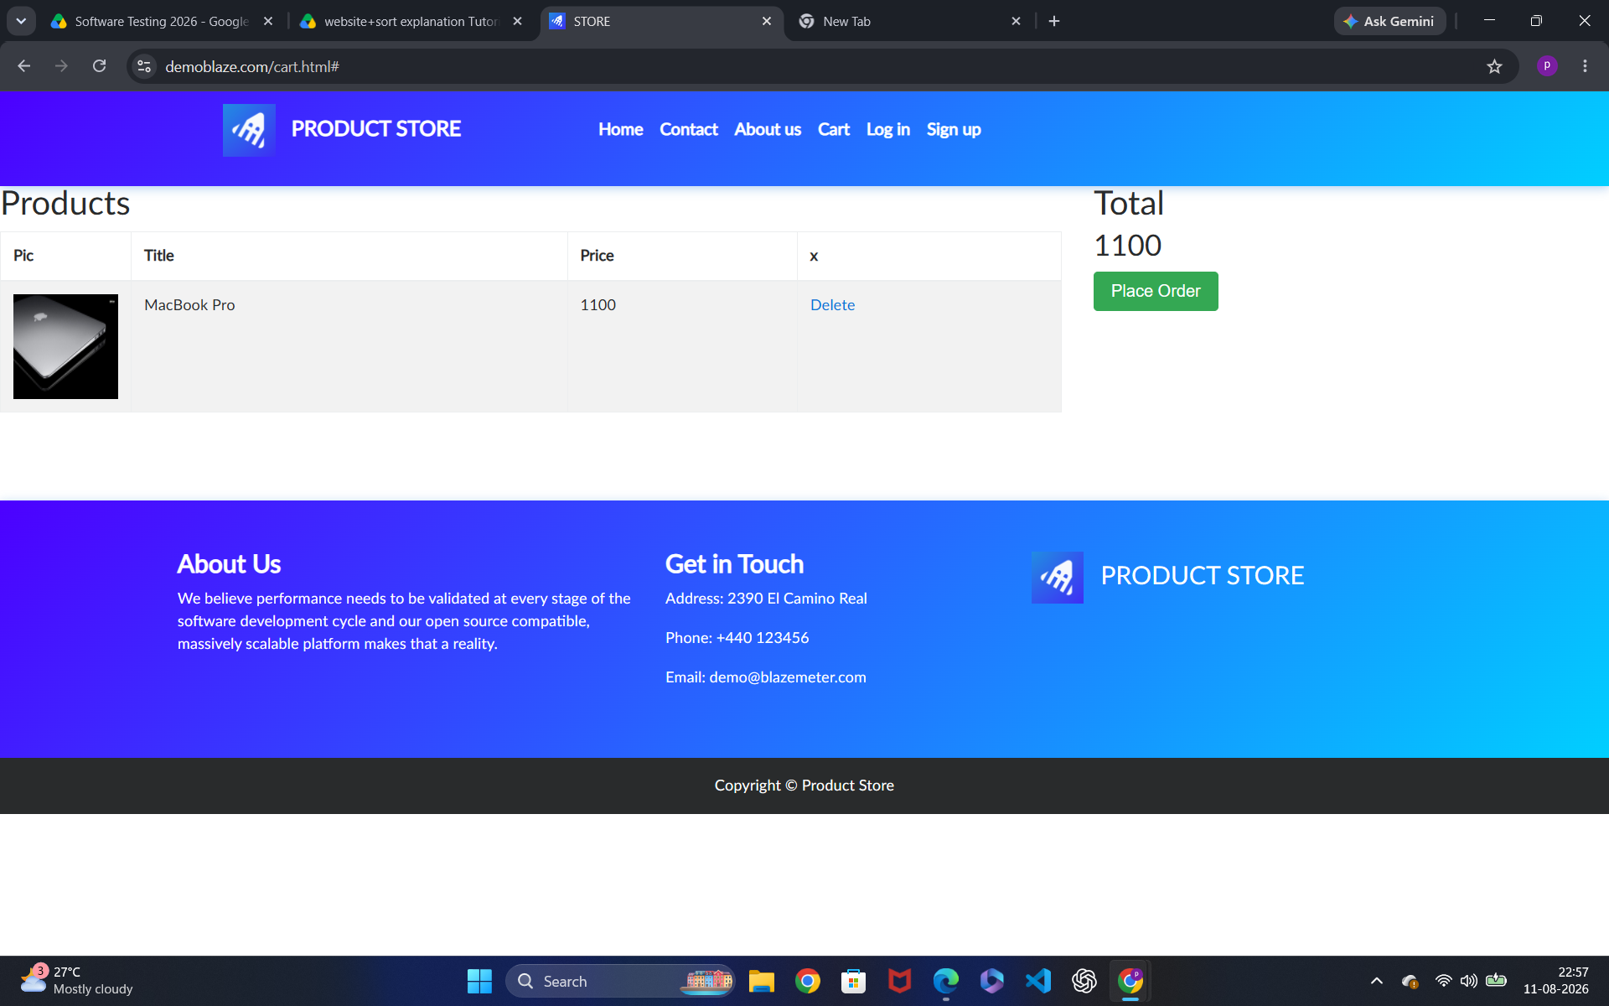

● Scenario ID: 1

Scenario: View Products

Test Steps:
1. Tap on delete icon

Screenshot:-

